If 2 devices are connected, that counts as a network
Networks mut be consistent and standard
HTML counts for this
Protocols need to be revisited, POP and whatever
What on earth is a UDP

Layers
Application
Transport
Internet
Data link
Physical

Open systems interconnection model (OSI)
Application
Presentation
Session
Transport
Network
Data link
Physical

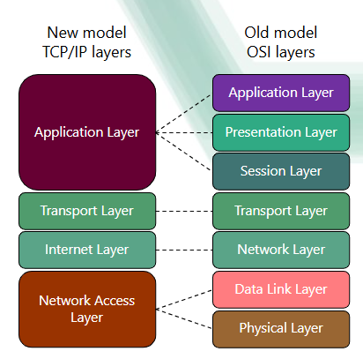

Data is split up into packets
Gaps in knowledge here()()()
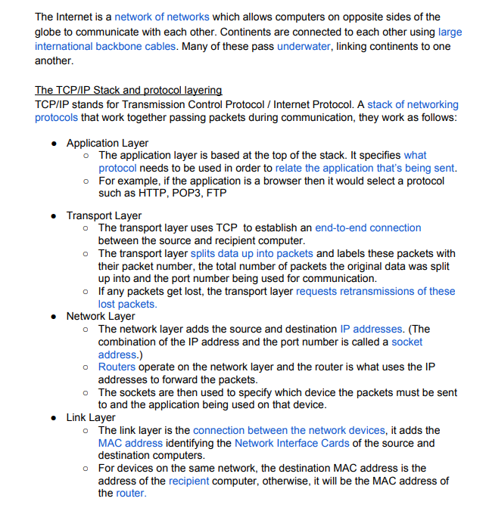
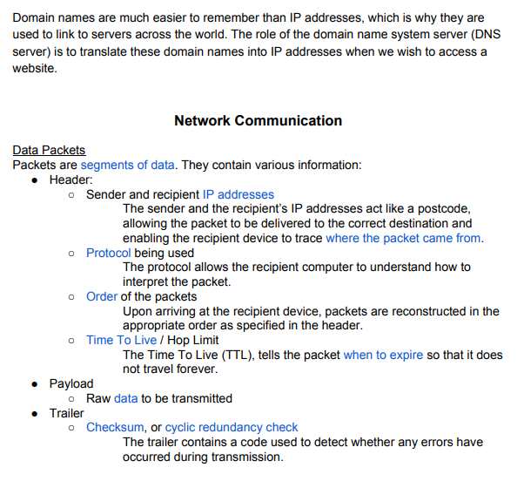
IP addresses / MAC addresses
MAC – Media address control
MAC address fixed to a device
IP address dynamic
MAC Address linked to IP Address

Router is on a WAN
LAN looks at MAC addresses
Oh my fucking god this teacher is worthless
WAN looks at IP address

New lesson:
Aim of network security is to prohibit unathorized access, and minimize damage done if they do get in

Black hat hackers: Criminal hackers
White hat hackers: Ethical hackers
Grey hat hackers: Breaking big networks as a hobby

DoS: Flooding a network with useless traffic, overloading the system
One device to another
DDOS: Using zombies to flood traffick, much harder to stop

SQL injection, entering code in input boxes to try and get in to the system

Social engineering: Scams
Phishing, standard scam links
Pharming, I don’t know look again ###################
Firewalls, (Both hardware and software) blocks IP addresses/ Traffic

Proxy servers, like a firewall on a WAN level, ensuring no direct link between a user and a remote source, and stopping access to anything on the proxy servers Ban list.

Encryption, doesn’t stop you from being hacked, but makes the hacked data harder to read

NETWORKS
Client server/ Peer to peer server

Client Server – all Clients are connected directly to 1 server, managing internet access and back ups
Advantages: Easier to manage files/Install files
Disadvanatges: Expensive to set up, requires a specialist to set up, single point of failure

Peer to Peer Server – the network is just the connection between each Peer (Computer)
Advantages: Much easier to maintain, doesn`t have Clients disadvantages
Disadvantages: Much more vulnerable security wise, harder to find specific data

Peer to Peer can have a client server thing, in private lobbies the host becomes the Server.

